GO Math! Grade 2 Chapter Test Alignment

This assessment guidance is designed as a companion to the Go Math K-5 Guidance Documents. It provides support for modifying GO Math! Chapter Tests to align to the changes recommended in the Guidance Documents. The changes include rationale, often guided by the Rule of Thumb for Assessments, provided in Part 2 of the Guidance documents:

- Eliminate any questions aligned to lessons/content that have been deleted.
- Add vetted questions aligned to lessons that have been added.
- Remove any directions in questions that require a specific strategy or model. Note: This is the only modification we will be making to questions.

In addition, the aspect(s) of rigor targeted by the standards for the chapter has been identified. Some changes to questions are based on alignment to the appropriate aspect of rigor.

Chapter 3
Based on the standards addressed in the chapter, this assessment should address the following aspects of rigor:
✓ Procedural Skill/Fluency
✓ Conceptual Understanding
Application

Grade 2 / Chapter 3: Basic Facts and Relationships
Problem # | Action  (Keep/ Modify/ Delete) | Details for the Action | Rationale
1 | Keep
2 | Delete |  | Assessment Rule of Thumb: Question requires a specific strategy.
3 | Keep
4 | Modify | Delete “Show how you can make a ten to find the sum,” and the equation 10 + ___ = ____. | Assessment Rule of Thumb: Question requires a specific strategy.
5 | Keep
6 | Delete |  | Guidance Document: Lesson deleted
7 | Modify | Delete the last sentence. Add the equation 13 - 5 = ___ under the question. | Aspects of Rigor: The standard targets fluency, but this is an application question.
8 | Keep
9 | Keep
10 | Modify | Delete all directions, number tiles and the two lines at the bottom. | Assessment Rule of Thumb: Question requires a specific strategy.
11 | Delete |  | Guidance Document: Lessons deleted
12 | Modify | Delete the last three sentences. Add the equation 16 - 7 = ____ under the question. | Aspects of Rigor: The standard targets fluency, but this is an application question.

Questions to be added:
Added Lesson | Source | Question
3.0.1 | EngageNY, Grade 2, Module 6, End of Module Assessment: #1a | 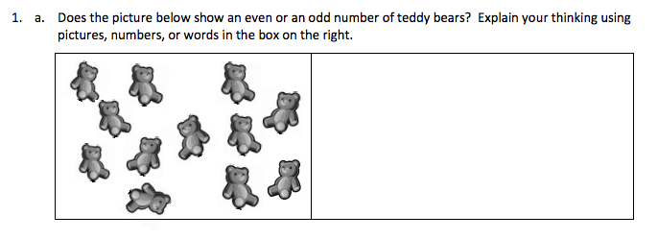
3.0.2 | GO Math!, Chapter 1 Test, # 2
3.0.2 | GO Math!, Chapter 1 Test, # 4
3.11.1 | Engage NY: Grade 2,Module 6 Mid-Module Assessment, #2a-b | 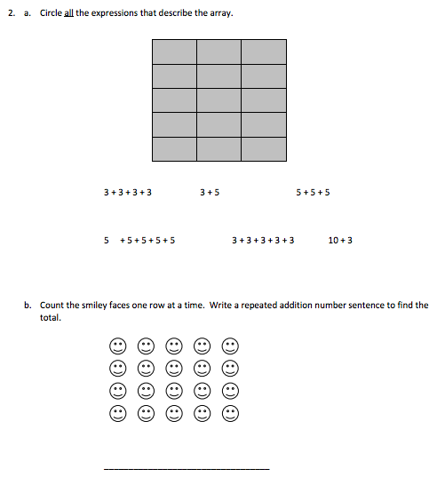

Chapter 2
Based on the standards addressed in the chapter, this assessment should address the following aspects of rigor:
✓Procedural Skill/Fluency
✓Conceptual Understanding
Application

Grade 2 / Chapter 2: Numbers to 1,000
Problem # | Action  (Keep/ Modify/ Delete) | Details for the Action | Rationale
1 | Keep
2 | Keep
3 | Keep
4 | Keep
5 | Keep
6 | Keep
7 | Delete |  | Aspects of Rigor: This standard targets procedural skill and this question targets application.
8 | Keep
9 | Modify | Change the last sentence of the first paragraph to read “Show a way to buy 355 straws.” | Assessment Rule of Thumb: Question requires a specific model.
10 | Modify | Delete the last paragraph and the box for quick pictures. | Assessment Rule of Thumb: Question requires a specific model.
11 | Keep
12 | Keep

Questions to be added:
Added Lesson | Source | Question
2.6.1 | Adapted from Illustrative Math, Looking at Numbers every which way | The picture below represents a number. Each stick represents 1, a bundle of sticks represents 10, and a bundle of ten bundles represents 100.  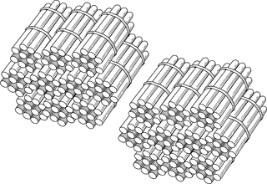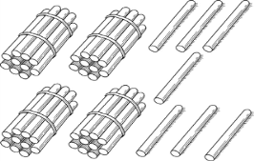  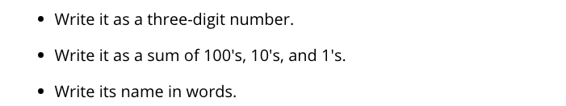
2.8.1 (Go Math Lesson 1.9) | EngageNY,Grade 2, Module 3 Mid Module Assessment, #1D | - Dora made her goal! She saved both ten dollar bills and hundred dollar bills to go from $400 to $900. Show how Dora could skip-count using tens and hundreds from 400 to 900. Explain your answer using words, pictures, or numbers.
Chapter 4
Based on the standards addressed in the chapter, this assessment should address the following aspects of rigor:
✓Procedural Skill/Fluency
Conceptual Understanding
✓Application

Grade 2 / Chapter 4: 2-Digit Addition
Problem # | Action (Keep/Modify/Delete) | Details for the Action | Rationale
1 | Modify | Delete the sentence “Label the bar model” and the bar model diagram. | Assessment Rule of Thumb: Question requires a specific strategy.
2 | Keep
3 | Keep
4 | Keep
5 | Modify | Delete the second paragraph. Delete the place value chart. | Assessment Rule of Thumb: Question requires a specific strategy.
6 | Delete |  | Guidance Document: Lessons deleted
7 | Keep
8 | Keep
9 | Modify | Delete “show how you can break apart…” and the corresponding graphics (blanks and arrows that force the use of breaking apart by place value). | Assessment Rule of Thumb: Question requires a specific strategy.
10 | Keep
11 | Keep
12 | Keep

Chapter 5
Based on the standards addressed in the chapter, this assessment should address the following aspects of rigor:
✓Procedural Skill/Fluency
Conceptual Understanding
✓Application

Grade 2 / Chapter 5: 2-Digit Subtraction
Problem # | Action (Keep/Modify/Delete) | Details for the Action | Rationale
1 | Modify | Just present the 4 problems and ask students to solve. | Aspects of Rigor: The standard targets procedural skill and this question focuses on conceptual understanding of a specific strategy.
2 | Modify | Delete the phrase “use the number line” and “count up to find the difference.” Take out number line. | Assessment Rule of Thumb: Question requires a specific strategy.
3 | Modify | Delete “Label the bar model” and the bar model diagram. | Assessment Rule of Thumb: Question requires a specific strategy.
4 | Modify | Delete the first sentence of the directions. | Assessment Rule of Thumb: Question requires a specific strategy.
5 | Modify | Same as #4 | Assessment Rule of Thumb: Question requires a specific strategy.
6 | Modify | Only use the first sentence of the item. | Assessment Rule of Thumb: Question requires a specific strategy.
7 | Modify | Delete the second paragraph and the bar model diagrams. | Assessment Rule of Thumb: Question requires a specific strategy.
8 | Modify | Present the subtraction problem without the boxes meant for regrouping. | Assessment Rule of Thumb: Question requires a specific format.
9 | Modify | Same as #8 | Assessment Rule of Thumb: Question requires a specific format.
10 | Keep
11 | Keep
12 | Modify | Delete the second sentence. | Assessment Rule of Thumb: Question requires a specific model.
13 | Keep
1 | Modify | Just present the subtraction problem and leave the explanation question at the end.  Make the tens/ones column space optional. | Assessment Rule of Thumb: Question requires a specific model.

Questions to be added:
Added Lesson | Source | Question
5.3.1 |  | The modified questions assess the extra lessons that were added to the Guidance Document.
5.3.2
5.3.3
**NOTE** |  | Only Chapters 4 and 5 address the OA.A.1 standard. There are not enough of the different problem types mentioned in the standard. As such, after Chapters 4 and 5, there should be an assessment on just OA.A.1. Use: http://achievethecore.org/page/258/representing-and-solving-addition-and-subtraction-problems-mini-assessment

Chapter 6
Based on the standards addressed in the chapter, this assessment should address the following aspects of rigor:
✓Procedural Skill/Fluency
Conceptual Understanding
Application

Grade 2 / Chapter 6: 3-Digit Addition and Subtraction
Problem # | Action (Keep/Modify/Delete) | Details for the Action | Rationale
1 | Modify | Add the equation: 368 - 291 = ___ | Aspects of Rigor: The standard targets procedural skill, but this is an application question.
2 | Modify | Add the equation: 121 + ___ = 863 | Aspects of Rigor: The standard targets procedural skill, but this is an application question.
3 | Keep
4 | Keep
5 | Modify | Delete “draw to show how you found your answer.”  Add the equation: 327 + 169 = ___ | Assessment Rule of Thumb: Question requires a specific strategy.  Aspects of Rigor: The standard targets procedural skill, but this is an application question.
6 | Keep
7 | Modify | Just present the word problem with the equation 305 - 263 = ____ Delete the rest of the item. | Assessment Rule of Thumb: Question requires a specific strategy.
8 | Modify | Delete the middle part where students would have to replicate Riley’s method. Leave Riley’s method and the question only where students describe how Riley solved the problem. | Assessment Rule of Thumb: Question requires a specific strategy.
9 | Modify | Add the equation: 288 + ___ = 497 | Aspects of Rigor: The standard targets procedural skill, but this is an application question.
10 | Delete |  | Assessment Rule of Thumb: Question requires a specific strategy.

Questions to be added:
Added Lesson | Source | Question
6.4.1 | Engage  NY, Grade 2, Module 5, End of Module Assessment: #1 & #3 | Addresses all added lessons:  The directions can be modified to: “Solve each problem.”  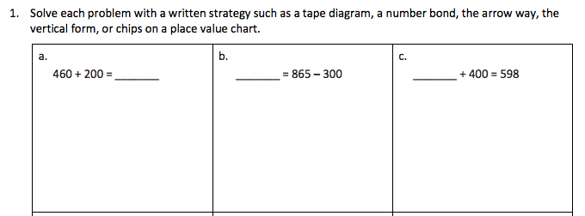  #3  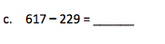  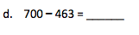
6.4.2
6.4.3
6.8.1
6.8.2
6.8.3
6.10.1
6.10.2

Chapter 7
Based on the standards addressed in the chapter, this assessment should address the following aspects of rigor:
✓Procedural Skill/Fluency
Conceptual Understanding
✓Application

Grade 2 / Chapter 7: Money and Time
Problem # | Action (Keep/Modify/Delete) | Details for the Action | Rationale
1 | Modify | Change $1.80 to 1 dollar and 80 cents or $1 and 80¢ | Chapter Rule of Thumb: 2.MD.C.8 does not require decimal notation when working with money
2 | Keep
3 | Keep
4 | Keep
5 | Keep
6 | Keep
7 | Delete |  | Guidance Document: Lesson deleted
8 | Keep
9 | Delete |  | Guidance Document: Lesson deleted
10 | Keep
11 | Keep
Chapter 8
Based on the standards addressed in the chapter, this assessment should address the following aspects of rigor:
✓Procedural Skill/Fluency
✓Conceptual Understanding
✓Application

Grade 2 / Chapter 8: Length in Customary Units
Problem # | Action (Keep/Modify/Delete) | Details for the Action | Rationale
1 | Keep
2 | Keep
3 | Keep
4 | Keep
5 | Keep
6 | Keep
7 | Keep
8 | Keep
9 | Keep

Questions to be added:
Added Lesson | Source | Question
8.4.1 | LearnZillion, Unit 3, Lesson 1 Additional Practice | 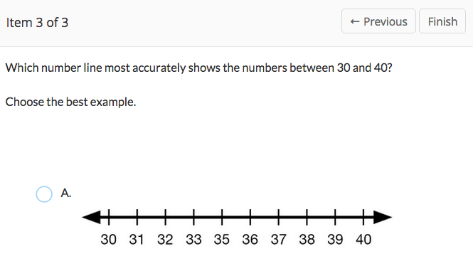  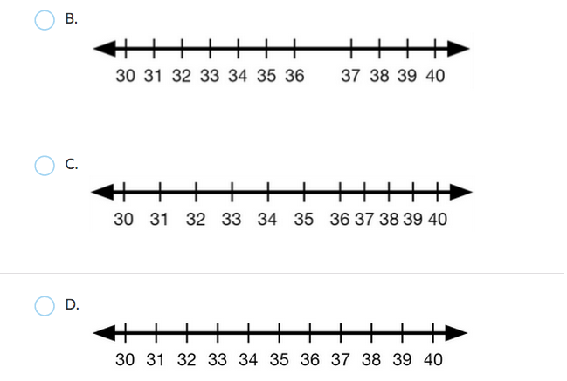

Chapter 9
Based on the standards addressed in the chapter, this assessment should address the following aspects of rigor:
✓Procedural Skill/Fluency
✓Conceptual Understanding
✓Application

Grade 2 / Chapter 9: Length in Metric Units
Problem # | Action (Keep/Modify/Delete) | Details for the Action | Rationale
1 | Keep
2 | Keep
3 | Keep
4 | Keep
5 | Keep
6 | Keep
7 | Keep
8 | Keep

Questions to be added:
Added Lesson | Source | Question
9.3.1 | Engage  NY, Grade 2, Module 2, End of Module Assessment: #3 | 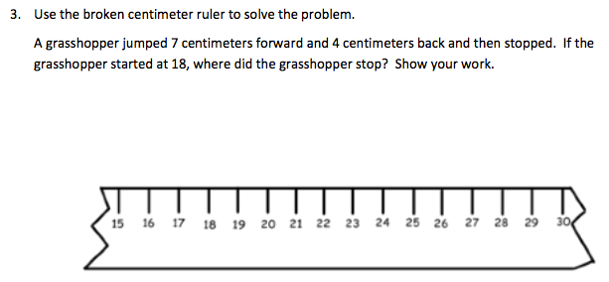

Chapter 10
Based on the standards addressed in the chapter, this assessment should address the following aspects of rigor:
✓Procedural Skill/Fluency
Conceptual Understanding
✓Application

Grade 2 / Chapter 10: Data
Problem # | Action (Keep/Modify/Delete) | Details for the Action | Rationale
1 | Keep
2 | Keep
3 | Keep
4 | Keep
5 | Keep
6 | Keep
7 | Keep
8 | Keep
9 | Keep
10 | Keep
11 | Keep
12 | Keep
13 | Keep

Chapter 11
Based on the standards addressed in the chapter, this assessment should address the following aspects of rigor:
✓Procedural Skill/Fluency
✓Conceptual Understanding
Application

Grade 2 / Chapter 11: Geometry
Problem # | Action (Keep/Modify/Delete) | Details for the Action | Rationale
1 | Delete |  | Guidance Document: Lesson deleted
2 | Keep
3 | Keep
4 | Keep
5 | Keep
6 | Keep
7 | Delete |  | Guidance Document: Lesson deleted
8 | Keep
9 | Keep
10 | Keep
11 | Keep

Questions to be added:
Added Lesson | Source | Question
11.7.1 | CPALMS Formative Assessment #46273  http://www.cpalms.org/Public/PreviewResourceAssessment/Preview/46273 | 